**FINAL CHECKS AND SUBMISSION**

We are in the final stretch. Now that you have your actual board, we need to do some final checks with the help of Altium and InstantDFM. We will also extract the necessary specifications so the manufacturer can print out our board.

1. To check for any invalidations to the rules, first we must implement our rules.
2. Go to Design > Rules…

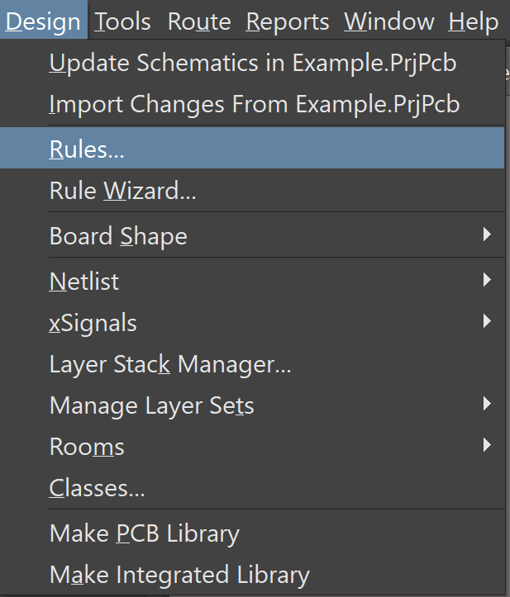

*Figure 1: Path to Rules…*

1. After the window opens, right click on the left column and select “Import Rules…”.

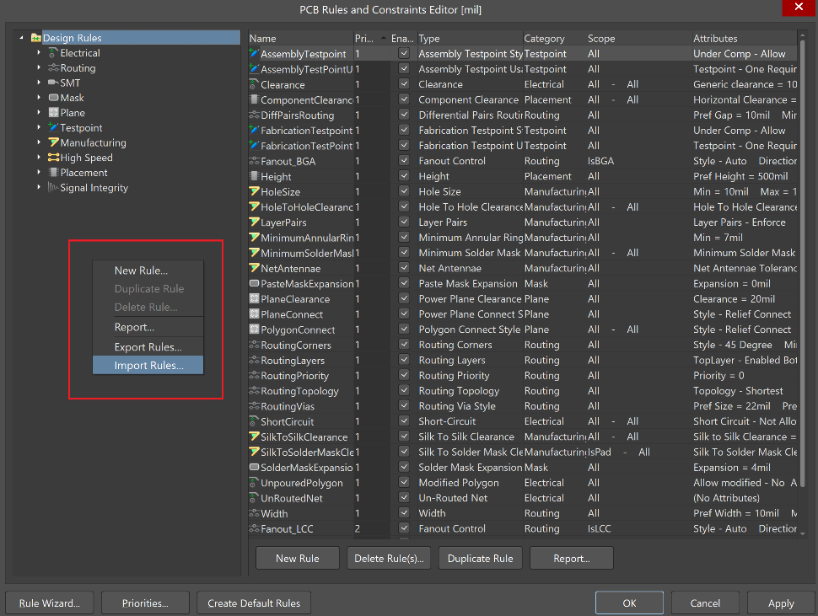

*Figure 2: Method to Import New Rules*

1. Press Ctrl+A to select all the rules, then press OK.

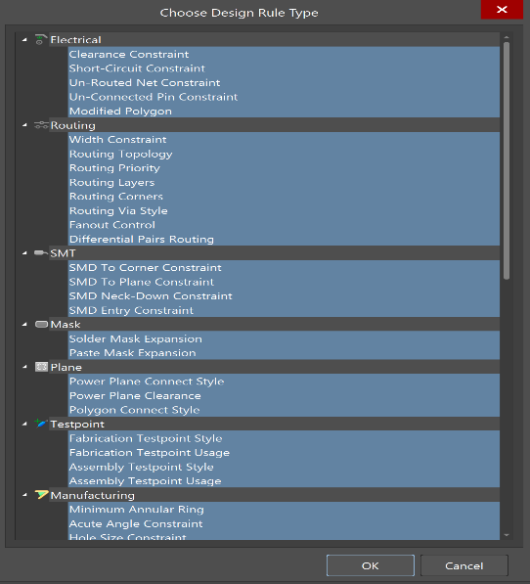

*Figure 3: List of Rules That You Will Replace*

1. Use the file “goodRules.RUL” by going to your GitHub repository and following the path: MIL > SVN Legacy > Subjugator SVN > subjugator8 > lib
2. When prompted to clear existing rules press “Yes”.

**

*Figure 4: File image of “goodRules”*

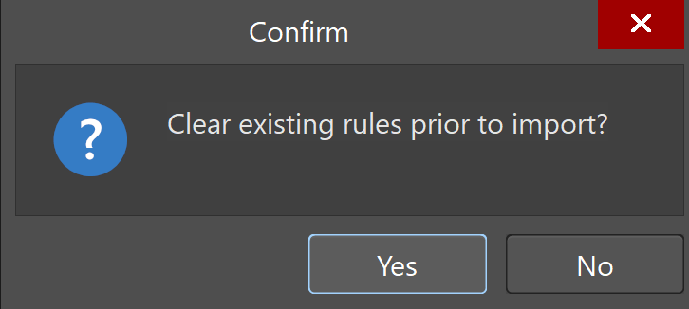

*Figure 5: Confirmation to Clear Existing Rule Set*

1. Now run a rule check by going to Tools > Design Rule Check…

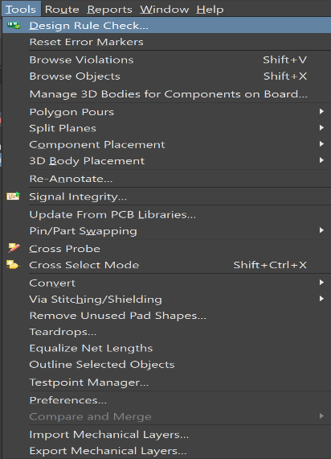

*Figure 6: Path to Design Rule Check*

1. Keep the defaults and select “Run Design Rule Check…” on the bottom left corner.

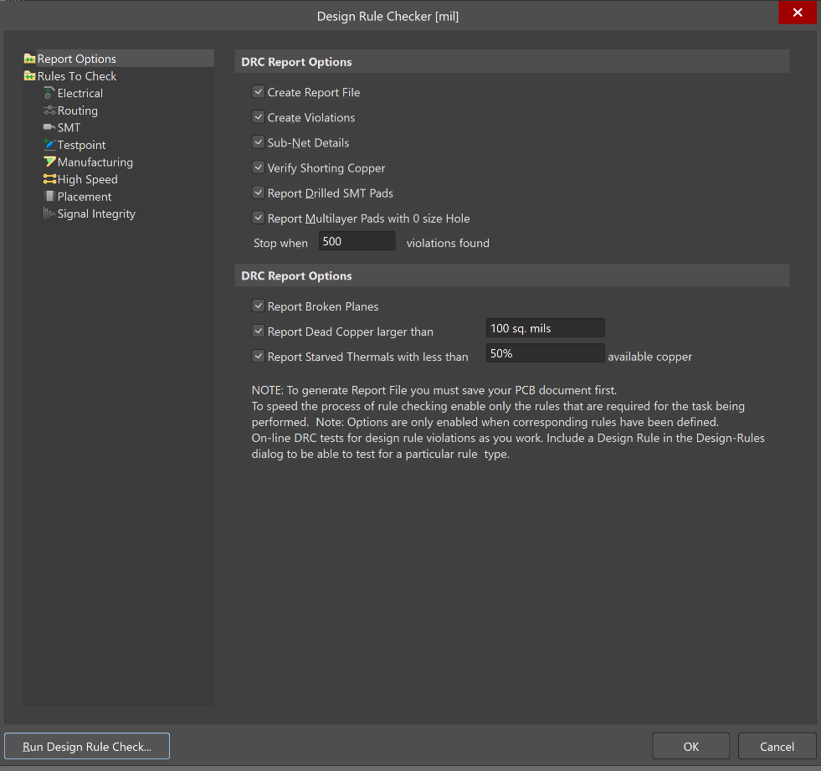

*Figure 7: Design Rule Check Window*

1. You should now see something similar to Figure 8.
2. You will see that we now have four errors. These are simple silk screen errors and can be ignored. More serious errors such as short circuit or unrouted net constraints need to be dealt with. When in doubt, reach out for help from a more senior member.

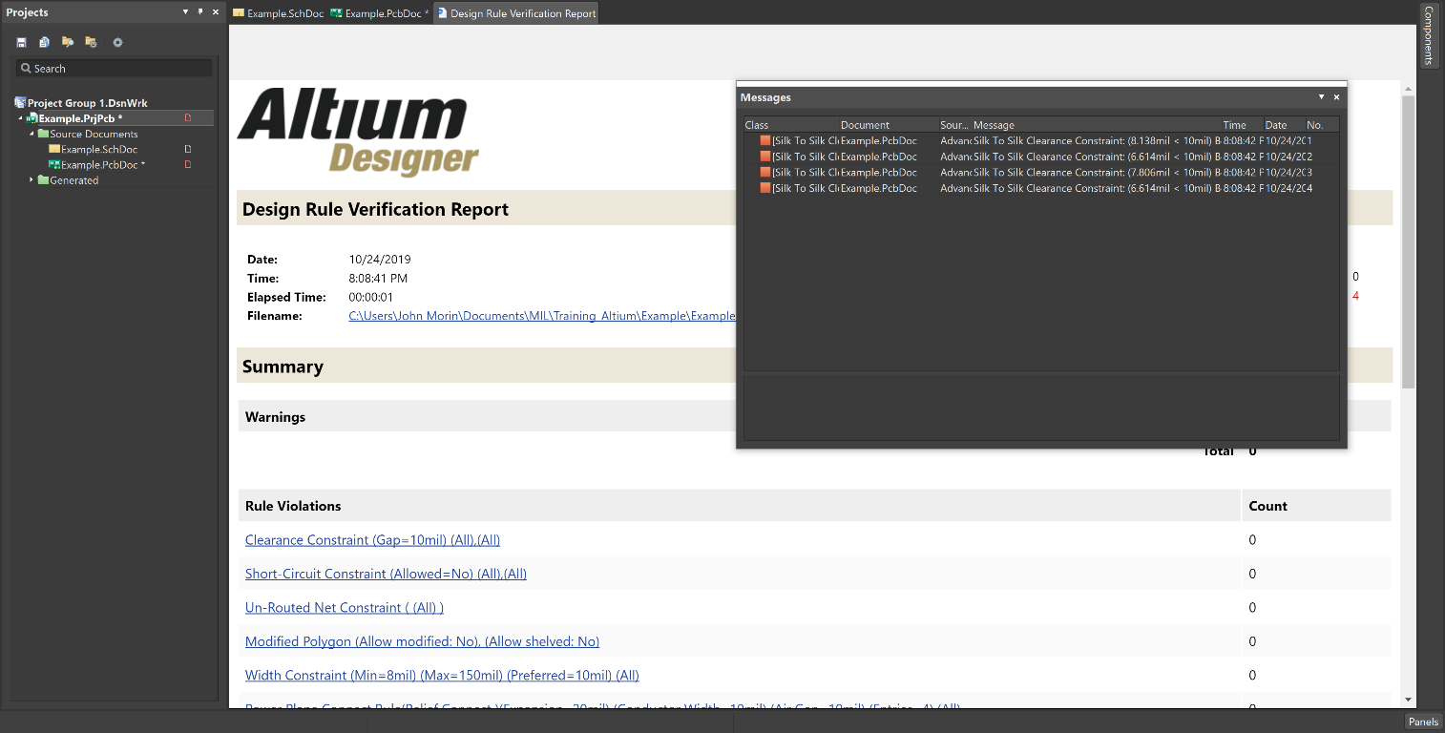

*Figure 8: Example Screen After You’ve Run Rule Check*

1. Now that we’ve completed our rule checking, we will start with the exporting process.
2. First go to File > Fabrication Outputs > Gerber Files.

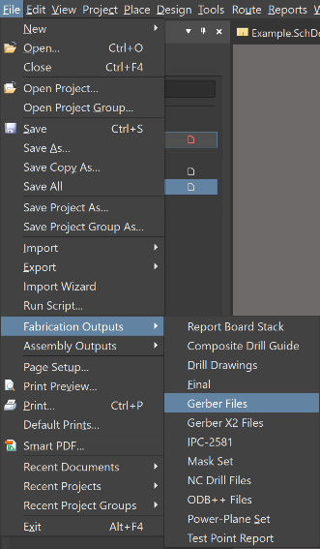

*Figure 9: Path to Gerber Files*

1. For the general format, select the unit that you used in your project (generally inches) and select the 2:5 Format.

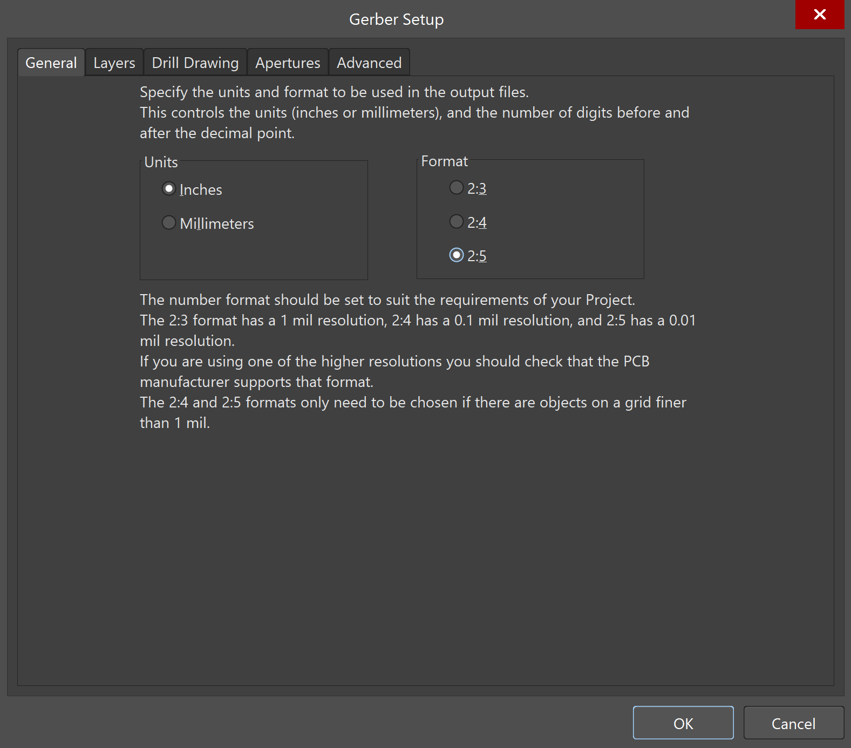

*Figure 10: General Gerber Setup*

1. Click on the “Layers” tab.
2. Towards the bottom, click the arrow next to “Plot Layers” and select “Used On” as shown in Figure 11.

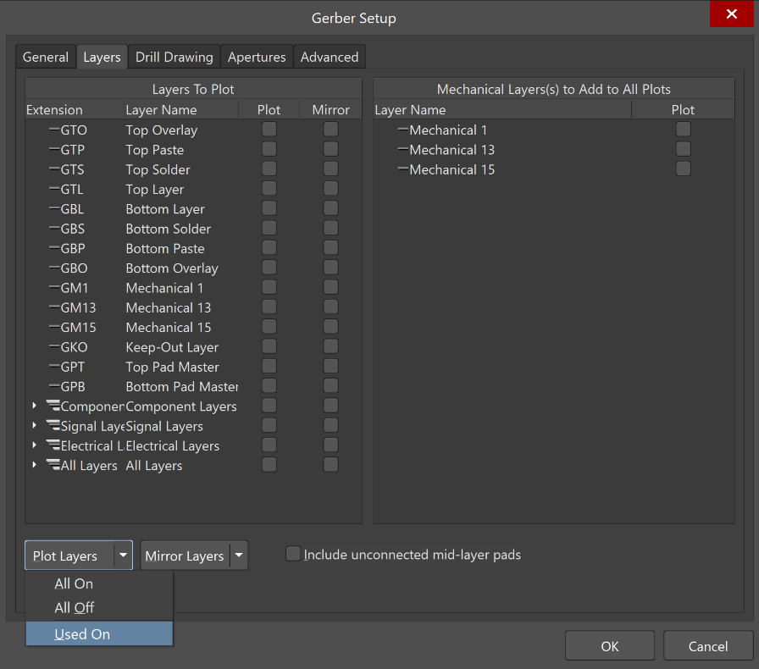

*Figure 11: Layers Gerber Setup*

1. You should see a new file created called “CAMtastic1.cam”.
2. Close this and do not save your changes.

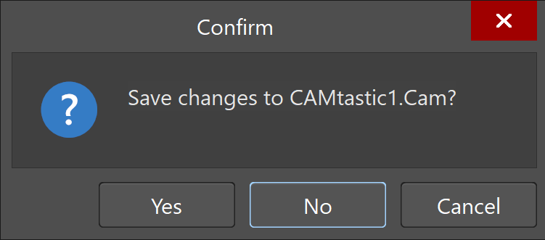

*Figure 12: Confirmation to Not Save*

1. Now we will create our Drill Files.
2. Go to File > Fabrication Outputs > NC Drill Files.

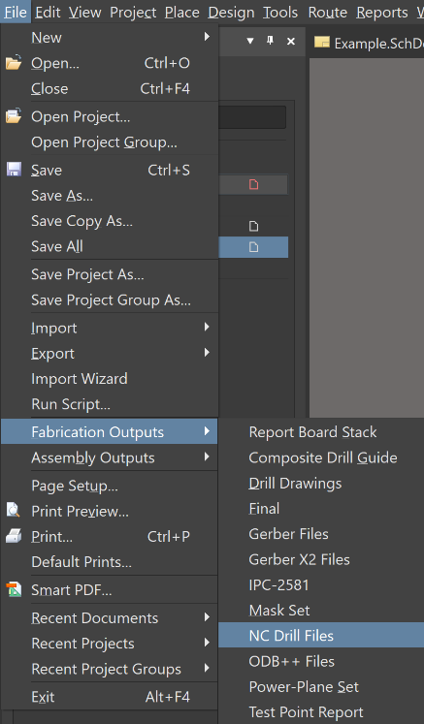

*Figure 13: Path to NC Drill Files*

1. Set your units and format to the same as your previous files and leave the rest as defaults then press OK.

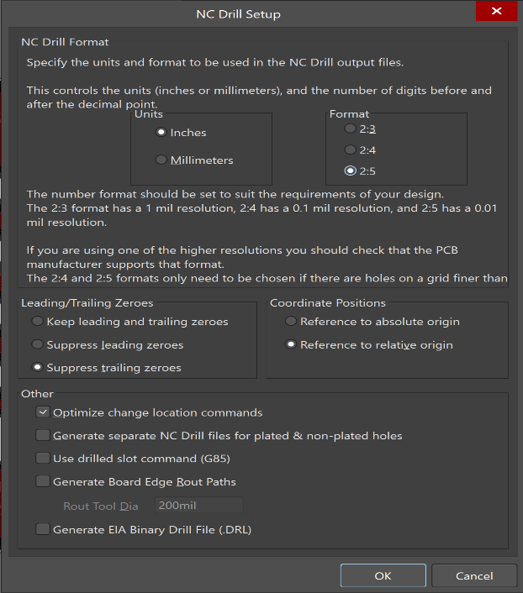

*Figure 14: NC Drill Setup*

1. Accept the defaults for you Drill Data and close the Camtastic document like before.

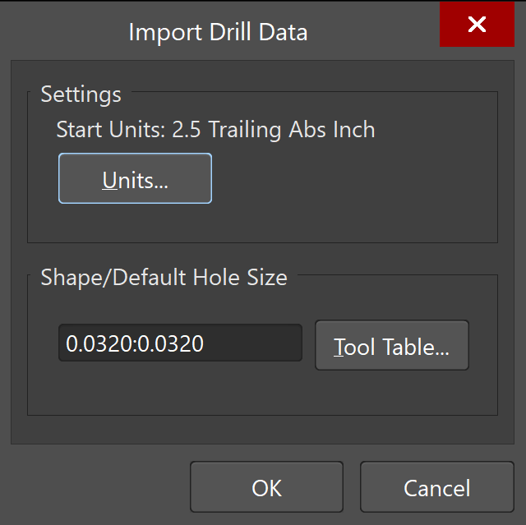

*Figure 15: Drill Defaults*

1. Go to the folder that your project is located and enter into the new folder “Project Outputs for XXX”.
2. Select all the files in this folder.

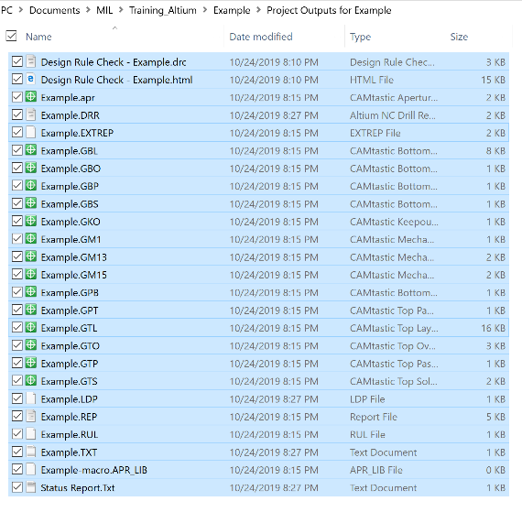

*Figure 16: Project Output files to be Zipped*

1. Send the files to a zip by right clicking, selecting “Send to” and then “Compressed (zipped) folder”.

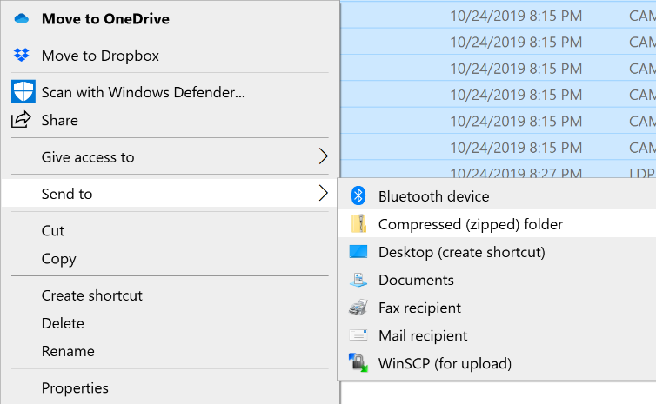

*Figure 17: Path to Zip File*

1. Go to <http://instantdfm.bayareacircuits.com/> and scroll down until you see the form in Figure 18.
2. Fill out the form with your personal and board details as specified below.
3. Upload the zip file that you made in Step 24 and submit.

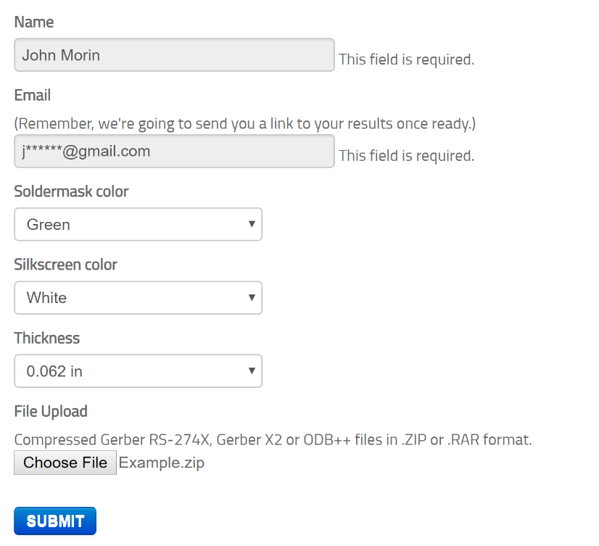

*Figure 18: Form on Instant DFM to submit board*

1. You will need to wait a couple minutes for your board to process.
2. Once your board is done processing, you should see confirmation similar to Figure 19 showing that everything is correct.
3. Some errors at this stage are acceptable but most imply there is something wrong with the design that is preventing manufacture. If you are unsure, contact a senior member.

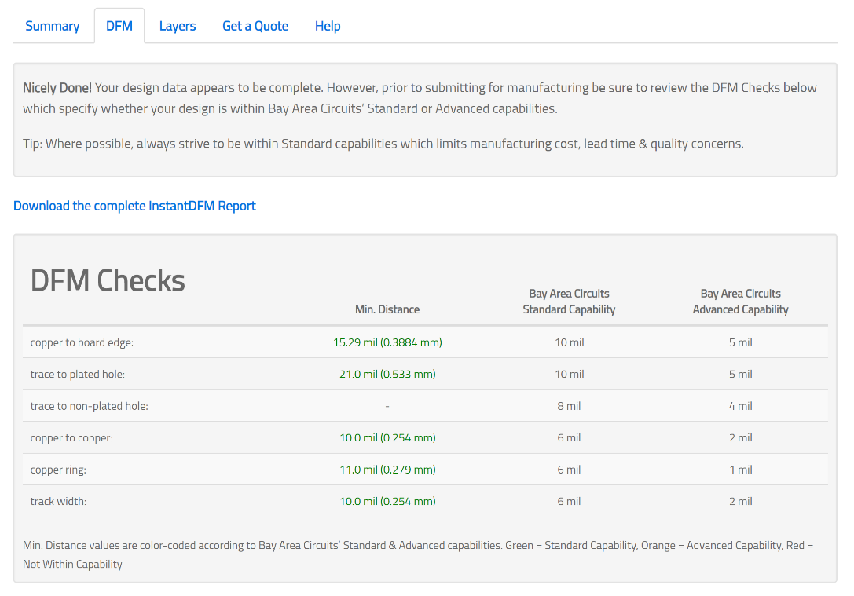

*Figure 19: Example of Verified Submission*

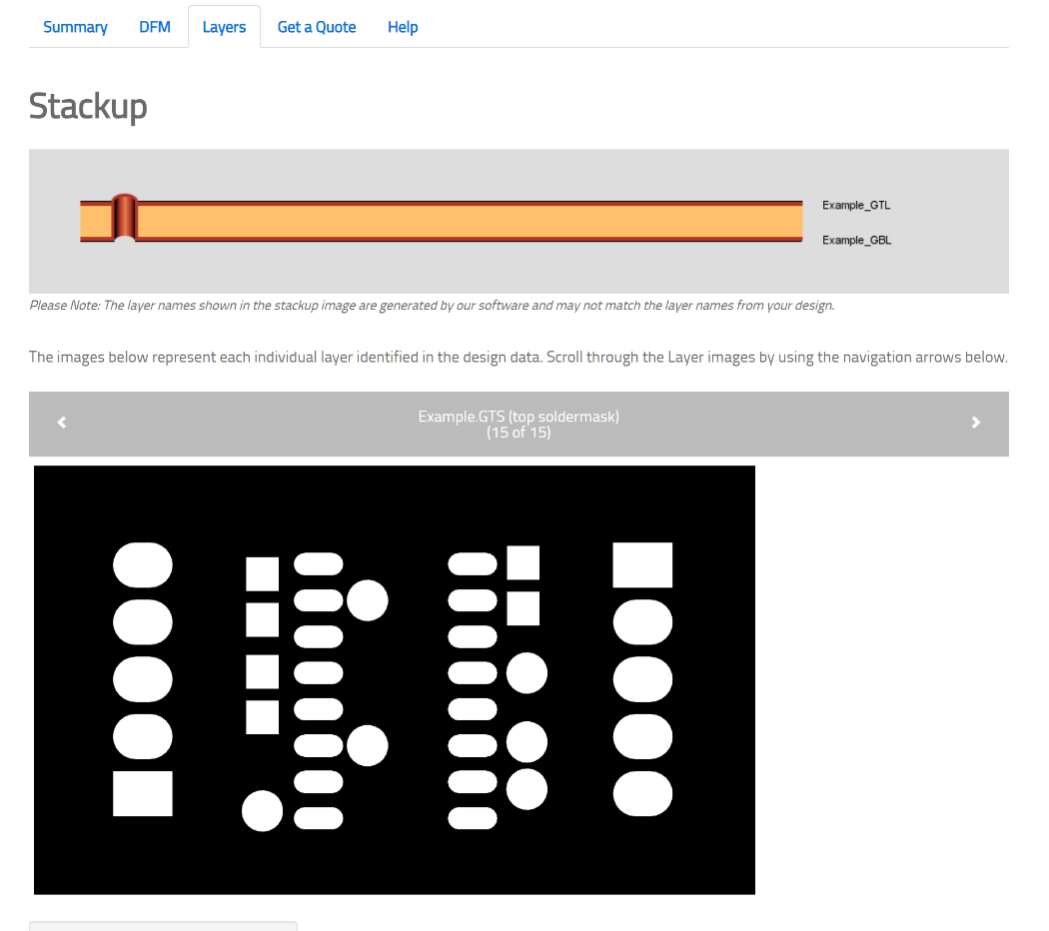

*Figure 20: Image of Layers the Manufacturer Receives for Printing*

1. Submit your .zip file to the proper senior member (usually electrical lead) and they will order it for you.
2. You have now successfully completed your first board! Crack open a cold one and enjoy your accomplishment, you’ve earned it!